**CDC Cognitive Testing Platform for Nonhuman Primates**

ECE4012 Senior Design Project

CDC Cognitive Testing Platform Team

Dr. Linda Milor

Centers for Disease Control

Collin Moore, [cmoore67@gatech.edu](mailto:cmoore67@gatech.edu)

Jonathan Procter, [jprocter3@gatech.edu](mailto:jprocter3@gatech.edu)

Ashwin Ramanathan, [aramanathan9@gatech.edu](mailto:aramanathan9@gatech.edu)

Samuel Yeomans, [syeomans3@gatech.edu](mailto:syeomans3@gatech.edu)

Nathan Zavanelli, [nzvanelli@gatech.edu](mailto:nzvanelli@gatech.edu)

Submitted

Aug. 30, 2019

# **Table of Contents**

**Executive Summary** 3

1. **Introduction** 4
   1. Objective 4
   2. Motivation 4
   3. Background 5
2. **Project Description and Goals** 6
3. **Technical Specification** 6
4. **Design Approach and Details** 
   1. Design Approach 8
   2. Codes and Standards 11
   3. Constraints, Alternatives, and Tradeoffs 12
5. **Schedule, Tasks, and Milestones** 12
6. **Project Demonstration** 13
7. **Marketing and Cost Analysis** 14
   1. Marketing Analysis 14
   2. Cost Analysis 15
8. **Current Status** 18
9. **References** 19

**Appendix A** 20

**Appendix B** 21

**Appendix C** 22

# **Executive Summary**

We are designing a cognitive testing platform to be operated by primates in cages at the CDC. A joystick will fit through the bars of the cage and allow the animal to move a cursor on the screen. A feeder system will distribute food pellets into the cage when the primate answers a question correctly. Currently, the CDC uses a legacy Windows XP system to perform the tests and an inefficient 24V DC motor for the feeder system which requires an external power supply to provide adequate voltage. Additionally, the feeder system was designed for pellets larger than the ones used by the CDC currently, sometimes distributing multiple pellets at once. We propose completely replacing this system with a Raspberry Pi and a modern 5V or less DC motor powering a feeding system specifically designed for the correct pellet size. This will also involve re-creating the tests in Python. We believe that replacing the entire system is necessary because the computer that is currently in use has become so slow that it is nearly unusable. The legacy Visual Basic code is inefficient and difficult for current CDC staff to use or develop, and the feeder is overly complicated and imprecise. We anticipate that it will cost $442.89 to replace the current system and for each additional system, which represents a 74.68% cost reduction per system built in the future versus the current cost of $1,749.21 per system. This includes the price of the Pi board, the DC motor, and other parts for the joystick and feeder. We believe that our system will be a massive improvement on the fifteen year old legacy system currently in use, more than justifying the cost of the project.

**CDC Computerized Cognitive Testing Platform for Non Human Primates**

**1. Introduction**

We intend to completely replace the current CDC cognitive testing platform. We are requesting $1280 to complete this project.

* 1. **Objective**

Currently, the CDC employs a system to test the cognitive abilities of non-human primates. A joystick is specifically designed to fit between the bars on a cage and allow the animal to manipulate a cursor on a monitor. A feeder system is also inserted into the cage, rewarding the primate with a food pellet for successfully completing the task. All of these systems are plugged into a central computer. Our objective is to recreate this system using modern, more efficient hardware and give the CDC documentation to make it easily replicable.

* 1. **Motivation**

The current iteration of the platform is powered by a legacy Windows XP system that is at least 15 years old and takes several minutes to boot up and shut down. The feeder system is not designed for the current pellet size, often dispensing more pellets than intended. It also requires an expensive external ADC converter to connect to the computer. Additionally, the code for the cognitive tests is written in Visual Basic, making it difficult for current CDC staff to create new tests. We have decided to completely replace the entire system because of these factors.

* 1. **Background**

Dr. James Weed of the CDC has designed these tests to measure the cognitive skills of these animals. After each series of tests, the results are collected and analyzed, giving staff additional data to evaluate the status of the primates. These tests give the monkeys something to focus on while they sit in their cages. The CDC’s internal data shows that monkeys that perform these tests are happier than idle animals. Additionally, these tests can help identify monkeys who are developing illnesses, as they become less interested in the tests and perform worse. We will create multiple platforms and provide adequate documentation to allow others to recreate our work, bringing these tests to more animals. Specifically, the current feeder used from Med Associates costs $450 USD and uses antiquated circuitry and controls. The cost of the entire system our team is proposing will be the same as the feeder from Med Associates, thereby reducing the cost of future replications of this prototype.

**2. Project Description and Goals**

The fundamental goal of the design team is to create a system that quantifies the cognitive abilities of lab animals at the CDC. To accomplish this goal, the design team will create a testing platform functionally similar to a video game with several different “game modes”. The system consists of a Raspberry Pi, a joystick, and a 5V DC motor working in tandem with a 3D printed feeder. The Raspberry Pi is a low-cost solution that can completely obsolete the CDC's current, outdated system. Each “game mode” will test and measure different cognitive abilities such as problem-solving, image recognition, and short-term memory retention. Upon completion of a cognitive task, the test subject will receive a banana-flavored food pellet to reinforce the behavior. The entire system is required to be designed in a way that is easy for the researchers at the CDC to use, clean, and set up from outside the animals’ enclosures. The features of the system include:

* Multiple “game modes” to test different cognitive abilities
* Dispenses food pellets when rewards test subject
* Can be set-up from outside an enclosure
* Can be easily cleaned by researchers

1. **Technical Specifications**

There are two hardware components that must be modernized on the platform. The first component is the computer running the games interacting with the monkeys. As specified in the original project submission, the Raspberry Pi Model 3 A+ must have processing capabilities to make interaction with the platform reliable, as detailed in Table 1. The second component is the pellet feeder: the client expressed a desire to scrap the current feeder and replace it with a cheaper DIY-type solution, which is described in Table 2. The current Visual Basic games on the platform must be rewritten in python such that the response time, feedback and customization must be equivalent to the current platform; this is further described in Table 3.

|  |  |  |  |  |  |  |  |  |
| --- | --- | --- | --- | --- | --- | --- | --- | --- |
| **Table 1:** Raspberry Pi Requirements   |  |  | | --- | --- | | **Feature** | **Requirement** | | ARM v8 Cortex-A53 [1] | 10-20 ms of delay in all actions | | GPIO Header Control Delay | 5 ms | | USB 2.0 Bitrate | 480 Mbps [2] | |

|  |  |  |  |  |  |  |  |  |  |  |
| --- | --- | --- | --- | --- | --- | --- | --- | --- | --- | --- |
| **Table 2**: Pellet Feeder Requirements   |  |  | | --- | --- | | **Feature** | **Requirement** | | Pellet Bowl | Does not become clogged with pellets | | Stepper Motor Electric and Mechanical Design | V_input = 3.2V, 200 PPR, I_input < 3A [3] | | Feeder Tube Measurements | Diameter = 2 x Diameter of Pellet, Length = 3’ | | Dispenser Module for pellets | Attach point = Outer Diameter of feeder tube | |

|  |  |  |  |  |  |  |  |  |  |  |  |  |
| --- | --- | --- | --- | --- | --- | --- | --- | --- | --- | --- | --- | --- |
| **Table 3:** Python Game Requirements   |  |  | | --- | --- | | **Feature** | **Requirement** | | Response time between signal and feedback | 20us | | Customization of Individual Game Parameters | Between Sessions by GUI | | Processor Overhead | 30-35% | | Formatting of Result Output | CSV | | Piping of Result Output | Serial | |

1. **Design Approach and Details**
   1. **Design Approach**

In order to create a cognitive testing platform that is high-speed, suited to distributing only one pellet, and modulary coded, we have decided on the following design approach. We will first work on three simultaneous objectives that will culminate in a testable device. Please reference appendix C for a PERT chart of the design approach.

The first path is to design and 3-D print the feeder apparatus. This will be a primary focus of the hardware team, requiring an extensive knowledge of CAD tools. While all members will learn how to work with CAD, this part of the project will be the primary focus of Nathan Zavanelli, Ashwin Ramanathan, and Samuel Yeomans. The design will be parametric so that changes can be made easily without the need to alter the entire design to implement a single change. We intend to document our CAD design so that it can be modified by future teams as necessary.

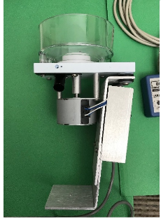

*Figure 1. The current feeder apparatus with 24V DC stepper motor. This design will be replaced with an improved version to fit both the new pellet size and our response time requirements.*

Our next path forms the critical path for this project: transferring the Visual Basic code to Python and configuring the Raspberry Pi to interface with the hardware. We anticipate that updating the legacy code will be the critical path, while interfacing with the new stepper motor and joystick peripherals will be parallel tasks. This path will be the primary focus of the software team under Collin Moore and Jonathan Procter. Ashwin Ramanathan will then work on interfacing with the peripherals. 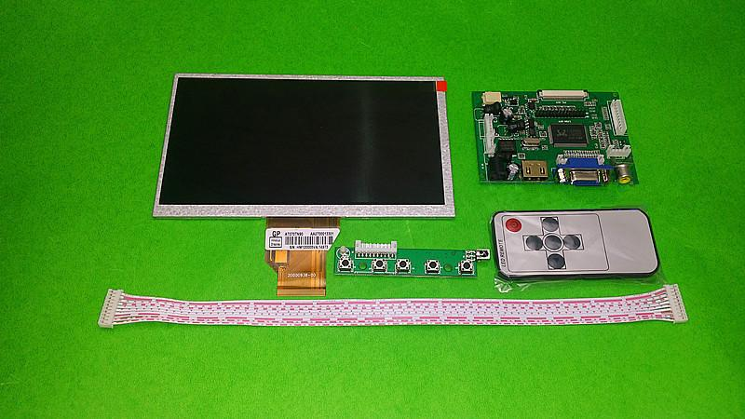

*Figure 2. The Raspberry Pi Model 3 A+ we will use with an example of a monitor and input peripheral setup*

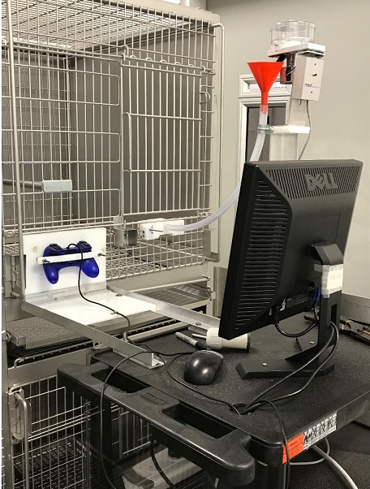

*Figure 3. The current monkey - computer interface using an Xbox controller and a computer running code written in visual basic.*

The third parallel path involves building the new enclosure for the apparatus and is the focus of a joint effort of members from both of the two other paths lead by Jonathan Procter. As there is relative stability in this path (i.e. once we receive the parts, we will know how long it takes to assemble them) as opposed to transferring the legacy code, this node will receive slightly less priority, yet will still be finished before the code and device interfacing even under our worst case scenario.

*Figure 4. The current apparatus without enclosure. Because the components are loose, they are more difficult to transport and more likely to break*. 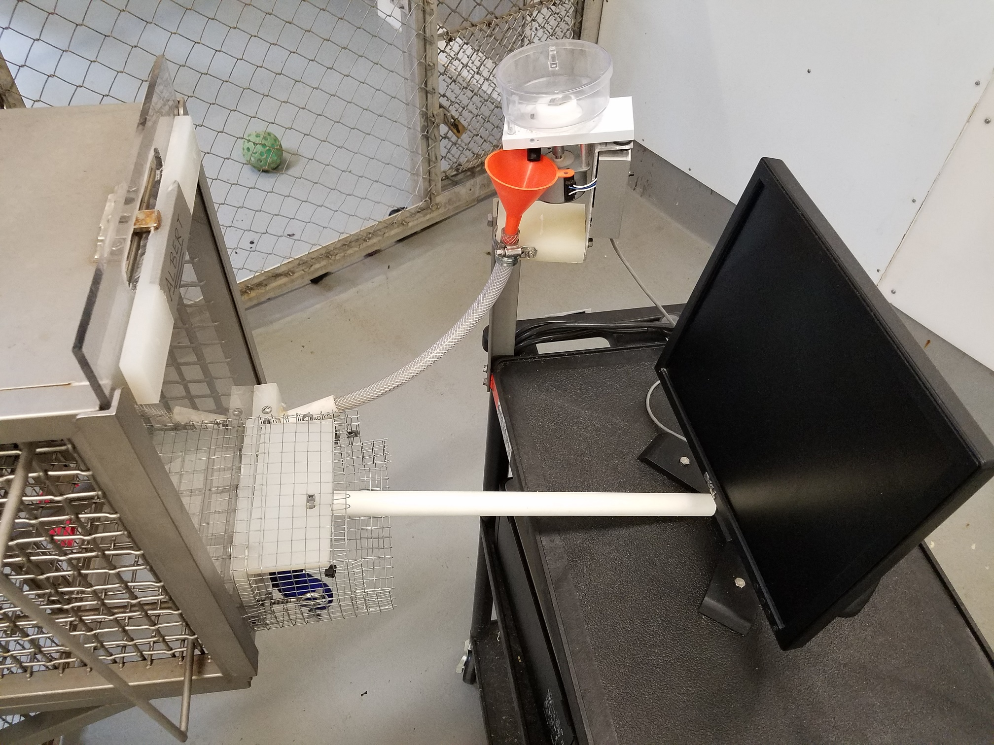

Once all of these paths have been completed, we will begin to test the apparatus. If successful, we will proceed to write a final summary, demonstrate performance to the client and conclude the project. If not, we will identify the errors and make revisions as necessary. Once the project is concluded, we will leave the client with a thorough documentation of our effort so that they can continue the project if a new need arises.

* 1. **Codes and Standards**

In order to successfully complete this project, there are several essential standards that must be met. First, we must adhere to the Center for Disease Control’s standards on animal safety and ethics. Specifically, we will need to consider the ways in which the platform interacts with, and potentially harms, the monkey subjects. Second, HID compliance standards will be important in coordinating the setup of the platform. Finally, the CDC has strong security standards which must be met.

* 1. **Constraints, Alternatives, and Tradeoffs**

Because of the nature of the lab, our testing apparatus must be attachable to the cages the animals are kept in. This puts certain sizing constraints on our design which will impact the decisions we make on what devices to include inside the apparatus. Lighter and smaller devices will be required for this solution. After use, the testing apparatus must be disinfected per lab policy. This will put a constraint on our design when considering materials used to encase the apparatus. Additionally, we must make sure the electronics of the apparatus are either resistant to the cleaning methods or consider additional materials to protect them. Additionally, the current cognitive tests are running off of Visual Basic code; we could potentially just implement this existing code onto the Raspberry Pi. This would greatly reduce the labor necessary to implement the tests, but it would come at the price of performance. Ultimately, we decided to completely recreate the tests in Python, a modern programming language which has much better performance on a Pi.

1. **Schedule, Tasks, and Milestones**

A list of tasks and the name(s) assigned per task is listed in Appendix A. Appendix B contains the GANTT chart showing the timeline of each task. Appendix C contains a PERT chart with a more detailed analysis of the critical path to complete the project.

1. **Project Demonstration**

Prior to the design expo, we will validate that the technical specifications outlined in **Tables 1-3** have been met with a live test at the CDC. This will be achieved by:

1. Successfully completing a game with the device under CDC supervision
2. Ensuring that the delay between response and feedback is sufficiently minimal as determined by a CDC expert.
3. Validating that the new feeder mechanism does not become jammed.
4. Validating that the output CSV is properly formatted for processing.

At the design expo, we will present a poster summarizing our results. We will not be able to show a live demonstration of the system or a video thereof for proprietary and safety concerns. In this presentation, we will discuss:

1. Project background
2. Statement of the problem to be addressed
3. Design solution techniques
4. Results of the improvement methods
5. Comparison to prior system
6. Conclusion
7. Handoff of intellectual property to the CDC.
8. **Marketing and Cost Analysis**
   1. **Marketing Analysis**

The primary target market for our cognitive testing platform consists of researchers who study primates, including our sponsor, the Center for Disease Control. The CDC already constructed their own platform running them around $1,749.21, as seen below in Figure 5 distributed to us by the CDC.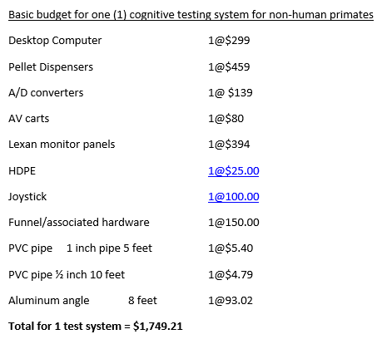

*Figure 5. Cost breakdown for one testing platform from the CDC*

The original CDC-built system features a commercial grade pellet dispenser from Med Associates Inc. [4] and a desktop computer used to control all of the I/O devices on it. Our new platform will include our own 3D-printed pellet dispenser and Raspberry Pi for I/O control, reducing the production cost by 74.68%.

* 1. **Cost Analysis**

Our total development cost for the testing platform prototype will be roughly $442.89, which has been determined based on the breakdown of cost in Table 4 below. The 3D print costs were estimated based on using the ABS material from Georgia Tech’s Invention Studio which is $17 per cubic inch [5]. The final design will most likely use much less material than indicated here. Stepper motor [3], driver circuit [6], Raspberry Pi [7], joystick [8], and monitor [9] costs were chosen based on large suppliers such as Sparkfun, Adafruit, and Amazon. The AV cart is the same as the one purchased by the CDC for their version.

|  |  |  |  |  |  |  |  |  |  |  |  |  |  |  |  |  |  |  |  |  |  |  |  |  |  |  |  |  |  |  |  |  |  |  |  |  |  |  |  |  |  |  |  |  |
| --- | --- | --- | --- | --- | --- | --- | --- | --- | --- | --- | --- | --- | --- | --- | --- | --- | --- | --- | --- | --- | --- | --- | --- | --- | --- | --- | --- | --- | --- | --- | --- | --- | --- | --- | --- | --- | --- | --- | --- | --- | --- | --- | --- | --- |
| **Table 4:** Prototype Cost Breakdown   |  |  |  |  | | --- | --- | --- | --- | | **Part** | **Quantity** | **Unit Price** | **Total Price** | | Raspberry Pi Model 3 B | 1 | $25.00 | $25.00 | | Cubic Inch of 3D-Printed ABS for Pellet Feeder (Bowl, Tubes, Dispenser) | 4 | $17.00 | $68.00 | | Cubic Inch of 3D-Printed ABS for I/O Enclosures | 6 | $17.00 | $102.00 | | Stepper Motor for Pellet Feeder | 1 | $30.95 | $30.95 | | Stepper Motor Driver Circuit | 1 | $14.95 | $14.95 | | AV cart | 1 | $80.00 | $80.00 | | Joystick | 1 | $25.00 | $25.00 | | Monitor | 1 | $66.99 | $66.99 | | I/O Cables | 1 | $30.00 | $30.00 | | **Total Cost** |  |  | **$442.89** | |

Development costs are broken down in Table 5 below, and were estimated based on $40 per hour labor. The activities listed and number of engineers per activity come from Appendix A. Fringe and overhead costs are factored into the higher costs and will be amortized over all units produced. Transferring the code to Python is the longest activity due to the nature of refactoring a codebase.

|  |  |  |  |  |  |  |  |  |  |  |  |  |  |  |  |  |  |  |  |  |  |  |  |  |  |  |  |  |  |  |  |  |  |  |  |  |  |  |  |  |  |  |  |  |  |  |  |  |  |  |  |  |  |  |  |  |  |  |  |  |  |  |  |  |  |  |  |  |  |  |  |  |  |  |  |  |  |  |  |  |
| --- | --- | --- | --- | --- | --- | --- | --- | --- | --- | --- | --- | --- | --- | --- | --- | --- | --- | --- | --- | --- | --- | --- | --- | --- | --- | --- | --- | --- | --- | --- | --- | --- | --- | --- | --- | --- | --- | --- | --- | --- | --- | --- | --- | --- | --- | --- | --- | --- | --- | --- | --- | --- | --- | --- | --- | --- | --- | --- | --- | --- | --- | --- | --- | --- | --- | --- | --- | --- | --- | --- | --- | --- | --- | --- | --- | --- | --- | --- | --- | --- |
| **Table 5:** Development Costs   |  |  |  |  | | --- | --- | --- | --- | | **Project Activity** | **Labor Hours** | **Number of Engineers** | **Labor Cost** | | Measurements at CDC | 5 | 5 | $1,000.00 | | Learn CAD | 20 | 5 | $4,000.00 | | **Feeder Development** |  |  |  | | Design Feeder in CAD | 30 | 2 | $2,400.00 | | Get Feeder 3D Printed | 20 | 1 | $800.00 | | Revision to Feeder | 40 | 5 | $8,000.00 | | **Code/Pi Development** |  |  |  | | Transfer Code to Python | 80 | 2 | $6,400.00 | | Interface new DC parts with Raspberry Pi | 30 | 1 | $1,200.00 | | **Enclosure Development** |  |  |  | | Build new enclosures for I/O | 40 | 2 | $3,200.00 | | **Testing** |  |  |  | | Trial Test Platform | 10 | 5 | $2,000.00 | | Revise Platform | 30 | 5 | $6,000.00 | | **Administrative** |  |  |  | | Meetings | 20 | 5 | $4,000.00 | | Demo Preparation | 10 | 5 | $2,000.00 | | Expo Preparation | 20 | 5 | $4,000.00 | | **Total** | **355** |  | **$45,000.00** | |

Using fringe benefit as 30% of total labor costs, and overhead as 120% of materials, labor, and fringe benefits, the total development cost for our testing platform is $129,674.36, as suggested by Table 6 below.

|  |  |  |  |  |  |  |  |  |  |  |  |  |  |  |
| --- | --- | --- | --- | --- | --- | --- | --- | --- | --- | --- | --- | --- | --- | --- |
| **Table 6:** Total Development Costs   |  |  | | --- | --- | | **Development Component** | **Cost** | | Parts | $442.89 | | Labor | $45,000.00 | | Fringe Benefits, 30% of Labor | $13,500.00 | | Subtotal | $58,942.89 | | Overheard, 120% of Material, Labor, & Fringe Benefits | $70,731.47 | | **Total** | **$129,674.36** | |

Our production will be over 5 years, with 1000 units sold per year, $800.00 each. Buying parts in bulk from suppliers reduces our parts cost to only $250.00 per unit. Technicians to assemble and test each platform will be hired for $20.00 an hour. Sales expense from advertising will make up 6% of the final price, which is $48.00. For $800.00 per platform, the expected revenue is $4,000,000.00, with a profit of $118.87 per unit. All production costs are broken down in Table 7 below. With an $800.00 price point, our testing platform is still significantly lower in cost compared to the CDCs original design.

|  |  |  |  |  |  |  |  |  |  |  |  |  |  |  |  |  |  |  |  |  |  |  |  |  |  |  |  |  |
| --- | --- | --- | --- | --- | --- | --- | --- | --- | --- | --- | --- | --- | --- | --- | --- | --- | --- | --- | --- | --- | --- | --- | --- | --- | --- | --- | --- | --- |
| **Table 7:** Selling Price and Profit Per Unit (Based on 5,000 unit production)   |  |  | | --- | --- | | **Income Component** | **Amount** | | Parts Cost | $250.00 | | Assembly Labor | $10.00 | | Testing Labor | $10.00 | | Total Labor | $20.00 | | Fringe Benefits, 30% of Labor | $6.00 | | Subtotal | $276.00 | | Overhead, 120% of Material, Labor & Fringe Benefits | $331.20 | | Subtotal, Input Costs | $607.20 | | Sales Expense | $48.00 | | Amortized Development Costs | $25.93 | | Subtotal, All Costs | $681.13 | | Profit | $118.87 | | **Selling Price** | **$800.00** | |

1. **Current Status**

As of the day this proposal was submitted, the CDC Cognitive Testing Platform Design Team has a schedule in place. Due to the transfer of the code into python being the critical path, we will plan to begin implementation of the games starting in May 2019 because it can be done remotely through a shared GitHub repository. Development will be done first through the group’s personal Raspberry Pi SBCs.

1. **References**

[1]"Raspberry Pi Model 3 A+", *Raspberrypi.org*, 2019. [Online]. Available: https://www.raspberrypi.org/app/uploads/2018/11/Raspberry_Pi_3A_product_brief.pdf. [Accessed: 16- Apr- 2019].

[2]"What are the USB data transfer rates and specifications? | Sony USA", *Sony.com*, 2019. [Online]. Available: https://www.sony.com/electronics/support/articles/00024571. [Accessed: 16- Apr- 2019].

[3]"Stepper Motor - 125 oz.in (200 steps/rev, 600mm Wire) - ROB-13656 - SparkFun Electronics", *Sparkfun.com*, 2019. [Online]. Available: https://www.sparkfun.com/products/13656. [Accessed: 16- Apr- 2019].

[4]"Pellet Dispenser (Pedestal) for Rat – 45 mg", *med-associates.com*, 2019. [Online]. Available: https://www.med-associates.com/product/pedestal-mount-pellet-dispenser-for-rat-45mg/. [Accessed: 19- Apr- 2019].

[5]"Professional 3D Print Submissions", *inventionstudio.gatech.edu*, 2019. [Online]. Available: https://inventionstudio.gatech.edu/professional-3d-print-submissions/. [Accessed: 19- Apr- 2019].

[6]"EasyDriver - Stepper Motor Driver", *Sparkfun.com*, 2019. [Online]. Available: https://www.sparkfun.com/products/12779. [Accessed: 19- Apr- 2019].

[7]"Raspberry Pi Model 3 A+", *adafruit.com*, 2019. [Online]. Available: https://www.adafruit.com/product/4027?gclid=Cj0KCQjw4-XlBRDuARIsAK96p3BfM1LO0TETECXU5fdsjXNiC3qZtMnBNt0iT-Vr-6GxQzXGo--bcS8aAn0vEALw_wcB. [Accessed: 19- Apr- 2019].

[8]"PS3 Controller Wireless 2 Pcs Double Shock Gamepad for Playstation 3, Six-axis wireless PS3 Controller with Charging Cable by Bowei", *amazon.com*, 2019. [Online]. Available: https://www.amazon.com/PS3-Controller-Wireless-Playstation-Bowei/dp/B07C86Q8KD/ref=sr_1_2_sspa?keywords=ps3+controller&qid=1555699282&s=electronics&sr=1-2-spons&psc=1. [Accessed: 19- Apr- 2019].

[9]"Sceptre E205W-16003R 20" 75Hz Ultra Thin Frameless LED Monitor 2x HDMI VGA Build-in Speakers, Metallic Black 2018", *amazon.com*, 2019. [Online]. Available: https://www.amazon.com/Sceptre-E205W-16003R-Frameless-Speakers-Metallic/dp/B07743412C/ref=sr_1_13?keywords=monitor&qid=1555699674&s=gateway&sr=8-13. [Accessed: 19- Apr- 2019].

**Appendix A**

|  |  |  |
| --- | --- | --- |
| **Activity** | **Lead** | **Assignees** |
| Parts Ordering | All members | Ashwin Ramanathan |
| **Transferring Code to Python** | Collin Moore | Collin Moore, Jonathan Procter |
| Measurements field day at CDC | Ashwin Ramanathan | All members |
| Learn CAD | All members | All members |
| Design Feeder in CAD | Nathan Zavanelli | Nathan Zavanelli, Samuel Yeomans |
| Get feeder 3D printed | Ashwin Ramanathan | Ashwin Ramanathan |
| Revisions to feeder | Ashwin Ramanathan | All members |
| Interfacing new DC parts with raspi | Ashwin Ramanathan | Ashwin Ramanathan |
| Building new enclosures for interactables | Jonathan Procter | Nathan Zavanelli, Jonathan Procter |
| **Trial test platform** | Ashwin Ramanathan | All members |
| Revise platform | All members | All members |
| **Oral Presentation** | Samuel Yeomans | All members |
| **Final Project demo** | Samuel Yeomans | All members |
| **Final Report** | Samuel Yeomans | All members |
| Prep for design expo | Jonathan Procter | Jonathan Procter, Samuel Yeomans |
| **Design Expo** | All members | All members |

**\*Bolded activity indicates project milestone**

## Appendix B

**Gantt Chart**

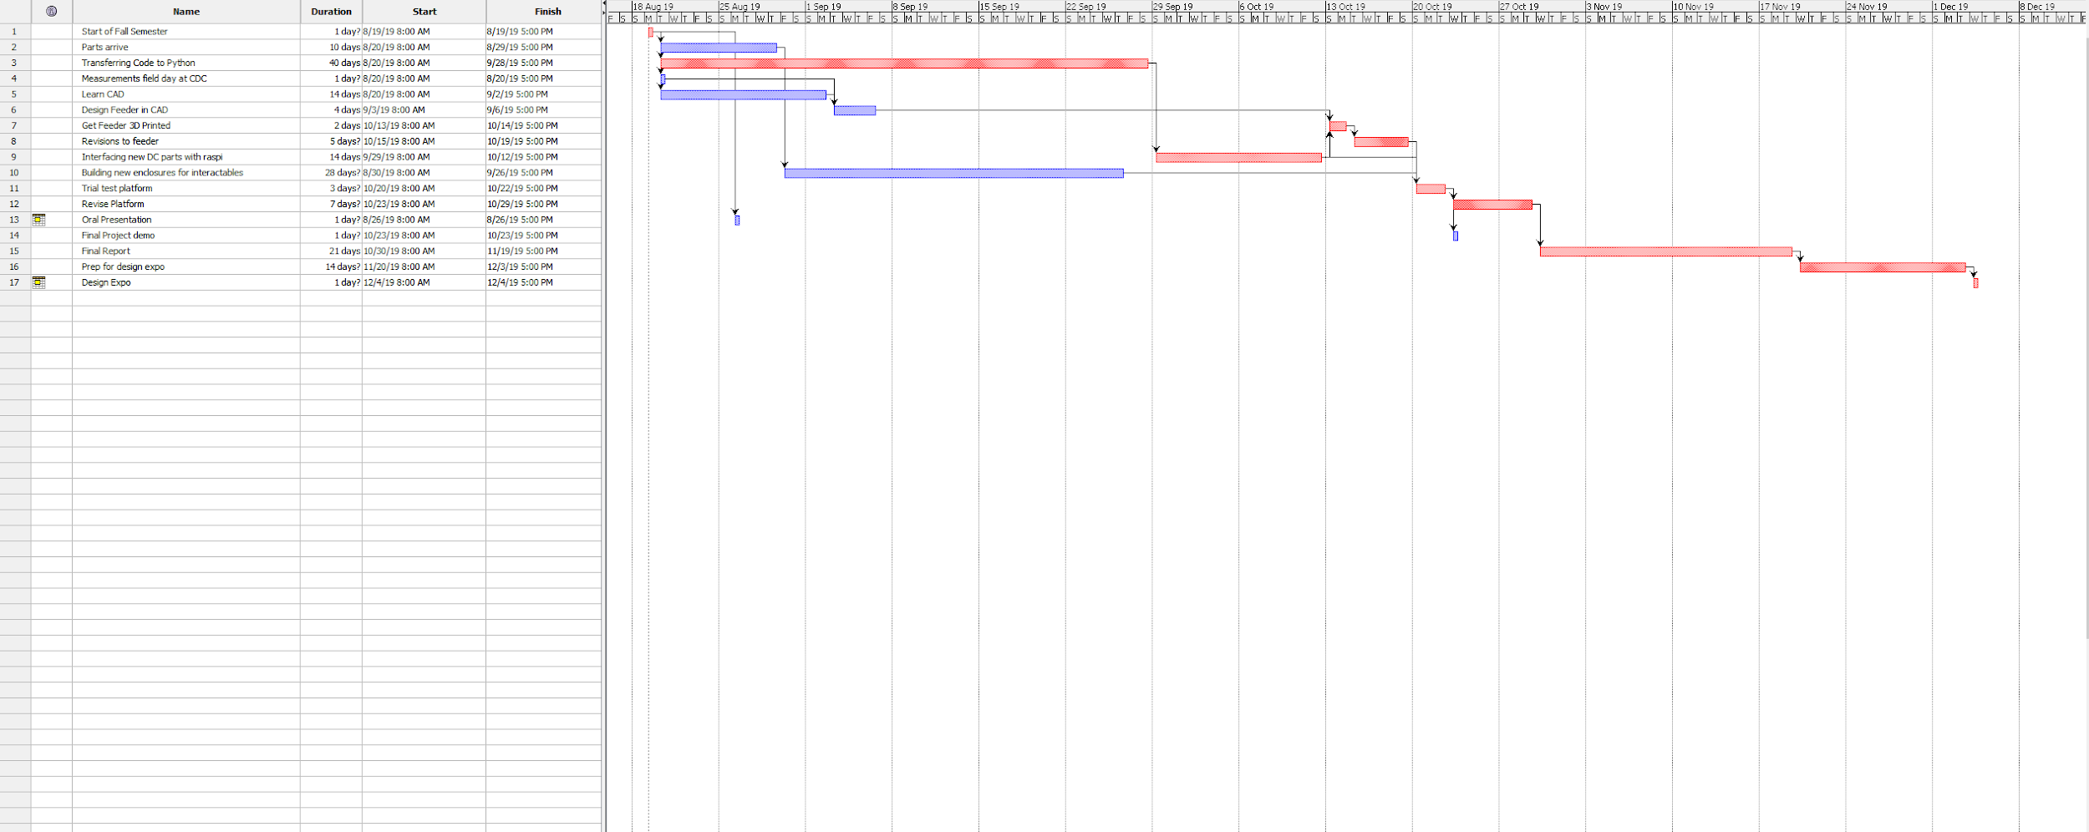

## Appendix C

**PERT Chart**

